Week 2 Task: Advanced Data Visualization and Storytelling with Python
Titanic Dataset – Visual Data Story

1. Introduction
This project demonstrates advanced data visualization and storytelling using the cleaned Titanic dataset. The aim is to convert passenger-level data into a simple visual narrative that can be understood by a non-technical audience. The analysis focuses on survival and examines how it varies with gender, passenger class, age, and fare.

2. Dataset and Domain
Domain: Transportation and historical passenger safety. The Titanic dataset contains information about passengers and whether they survived the disaster. The dataset is suitable for storytelling because it contains categorical and numerical variables and supports comparisons between different passenger groups.
Dataset size: 781 rows and 15 columns.
Main variables used: survived, sex, age, pclass, fare, embarked.

3. Methods and Visualization Approach
Python was used for data analysis and visualization. Pandas was used to load and prepare the dataset, while Matplotlib was used to create the charts. Different chart types were selected according to the question being answered: bar charts for group comparison, histograms for distributions, and a scatter plot for relationships between numerical variables.
The storytelling sequence moves from the overall survival outcome to group differences, then to demographic and numerical relationships. This structure helps the reader understand the main pattern before exploring possible factors associated with it.

4. Visual Analysis and Data Story

4.1 Survival Distribution
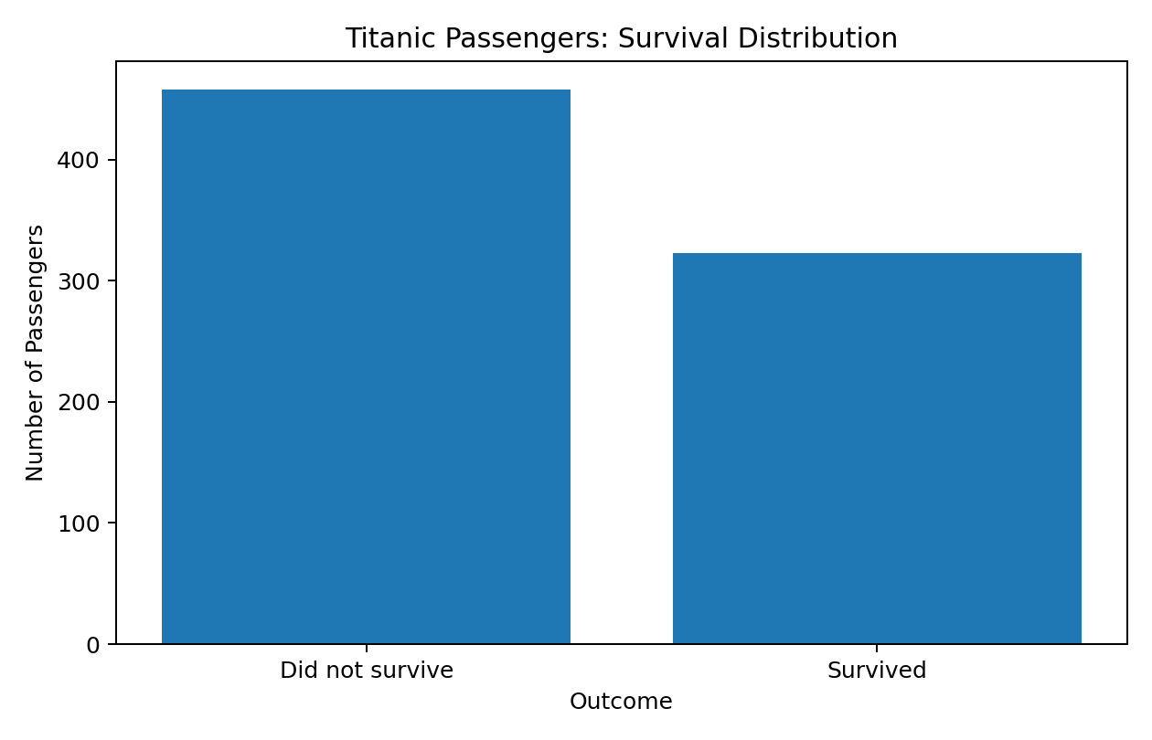
Figure 1: Survival Distribution
Narrative role: This chart establishes the main outcome of the dataset. It shows the imbalance between passengers who survived and those who did not, giving the audience the starting point for the story.

4.2 Survival by Gender
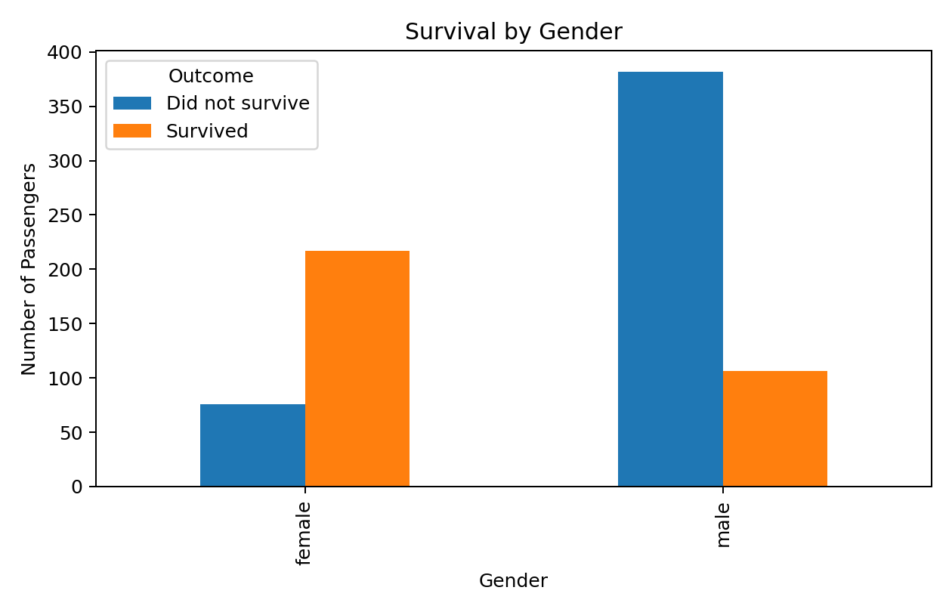
Figure 2: Survival by Gender
Narrative role: The grouped bar chart compares outcomes across genders. It highlights a strong difference in survival outcomes and helps explain that survival was not evenly distributed among passenger groups.

4.3 Survival by Passenger Class
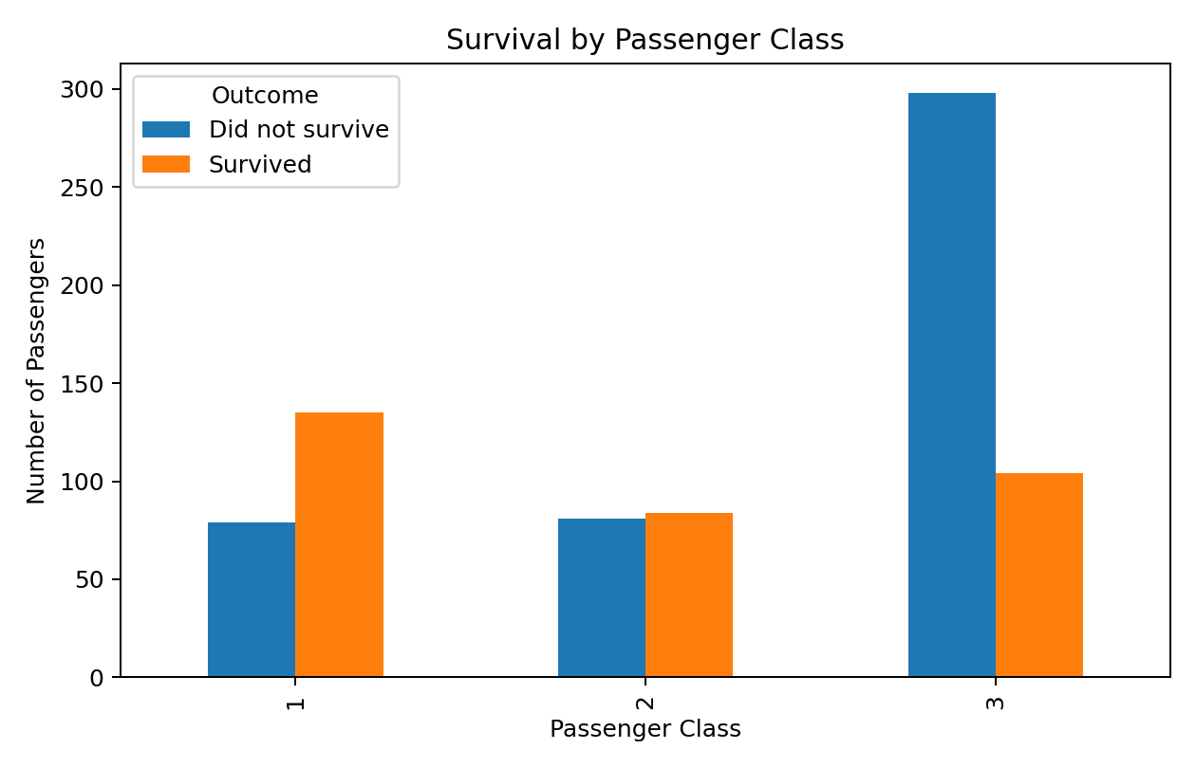
Figure 3: Survival by Passenger Class
Narrative role: This visualization adds socioeconomic context. Comparing passenger classes shows how survival outcomes varied across first, second, and third class, strengthening the narrative around unequal outcomes.

4.4 Age Distribution by Survival
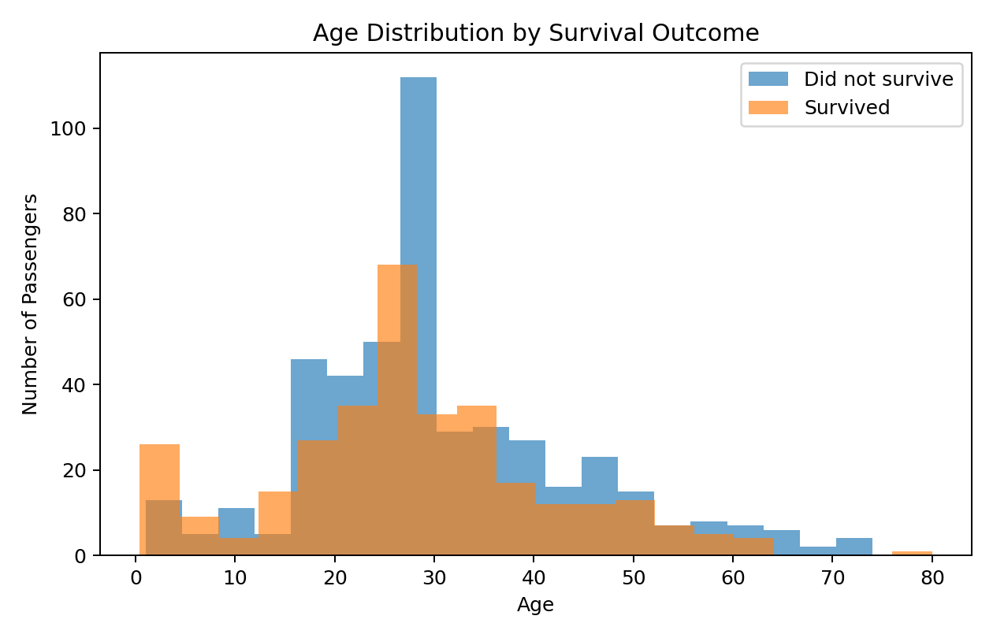
Figure 4: Age Distribution by Survival
Narrative role: The overlapping histograms show how age is distributed among survivors and non-survivors. This adds a demographic dimension and helps identify whether age groups appear differently represented in the two outcomes.

4.5 Age vs Fare and Survival
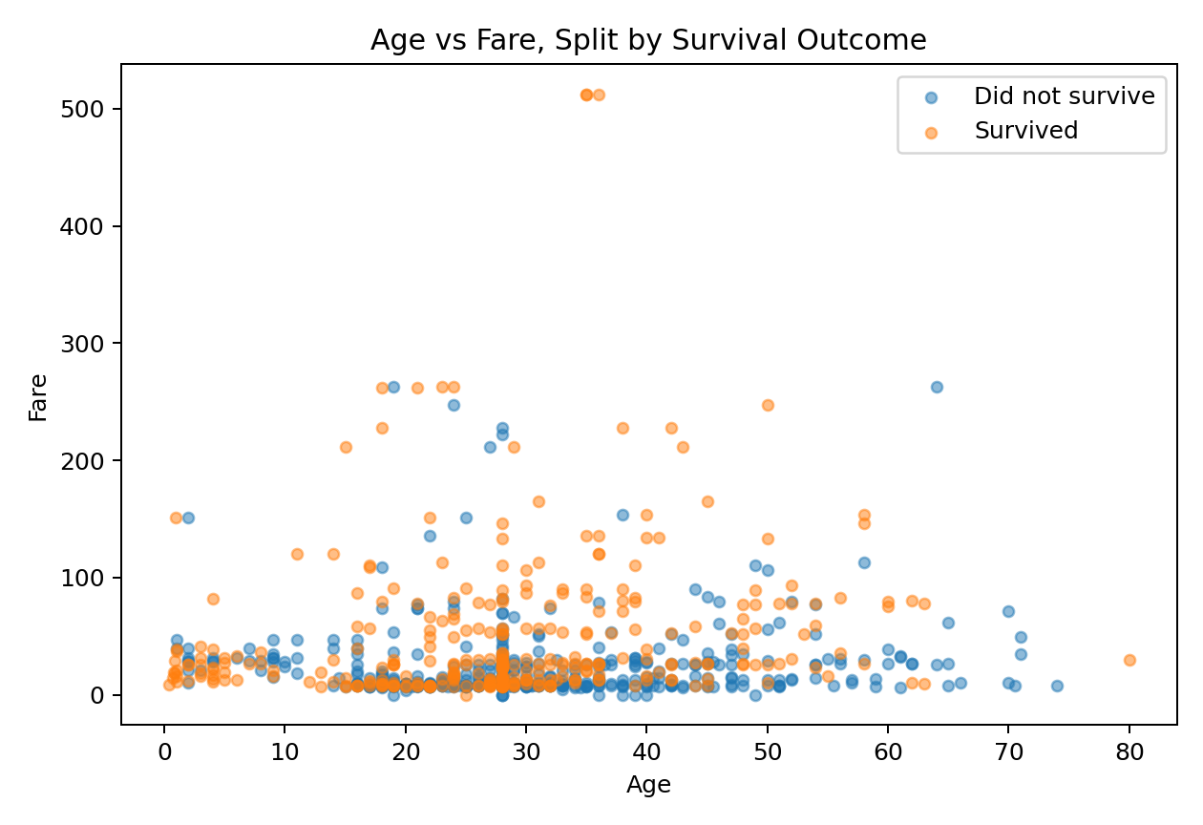
Figure 5: Age vs Fare and Survival
Narrative role: The scatter plot combines three variables: age, fare, and survival. It allows the audience to look for patterns that may be hidden in single-variable charts, especially the relationship between fare level and survival across different ages.

5. Key Insights
• Overall survival rate in the cleaned dataset is approximately 41.4%.
• Survival rates differ substantially between gender groups, indicating that gender is an important variable for understanding the outcome.
• Passenger class shows a clear relationship with survival, with survival rates varying across classes.
• Passenger age ranges from approximately 0 to 80 years in the available records, allowing age-based demographic analysis.
• Fare varies considerably across passengers, making it useful for exploring differences in passenger status and survival.

6. Business and Scientific Implications
The analysis demonstrates how data visualization can reveal unequal outcomes across population groups. In a business context, the same approach can be used to study customer segments, safety incidents, churn, or service outcomes. In a scientific or public-safety context, visual comparisons can help researchers identify variables that deserve deeper statistical investigation.
Importantly, these visualizations show associations rather than proving causation. A more advanced study would use statistical tests and predictive models to determine which variables remain important after controlling for other factors.

7. Conclusion
The Titanic dataset provides a clear example of data storytelling. Starting with the overall survival picture and progressively adding gender, class, age, and fare creates a coherent narrative. The five visualizations transform a raw dataset into an accessible story and demonstrate how chart selection, context, and explanation work together to communicate insights effectively.

8. Tools Used
• Python
• Pandas
• Matplotlib
• Microsoft Word / DOCX format

9. Compliance with Task Requirements
Requirement | Completed
Single DOC file | Yes
Introduction and methods | Yes
At least 5 visualizations | Yes
Explanation of each visualization | Yes
Data storytelling narrative | Yes
Business/scientific implications | Yes
Conclusion and readability | Yes

